**SCREENSHOTS**

Server output. Turning off server. From **http_server2.py** script

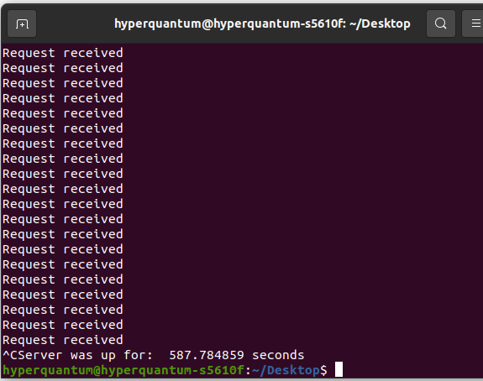

Output from assessing vulnerabilities. From **vuln_script.py – part 1**

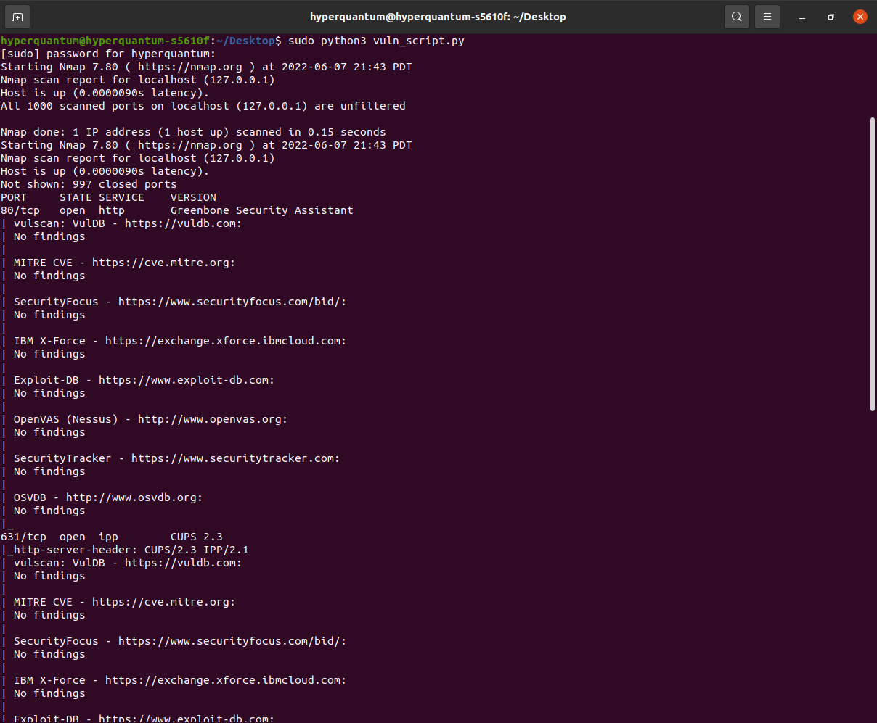

Output from **vuln_script.py – part 2**

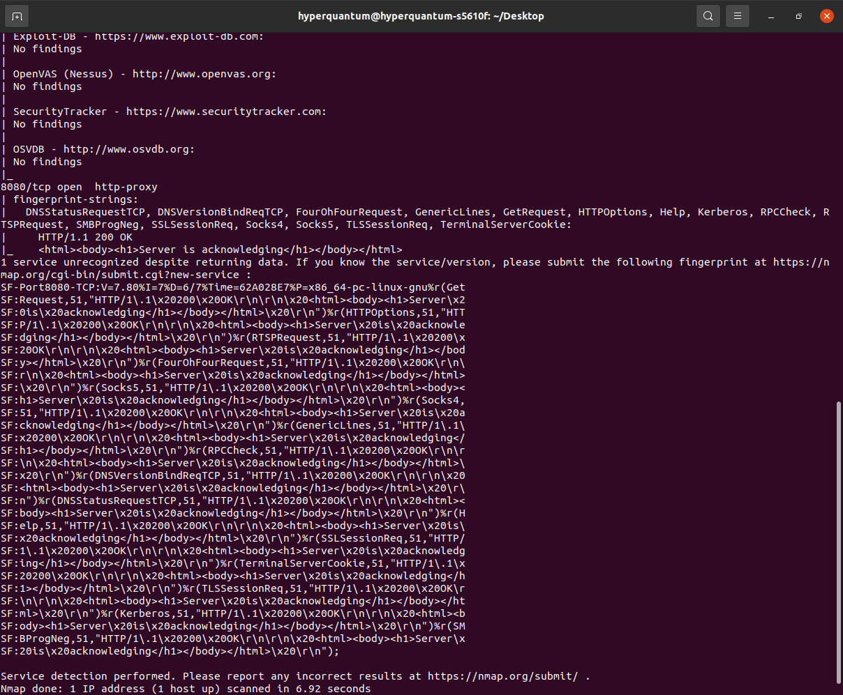

Server turned on and off. Output from monitoring script **check_status3.py** 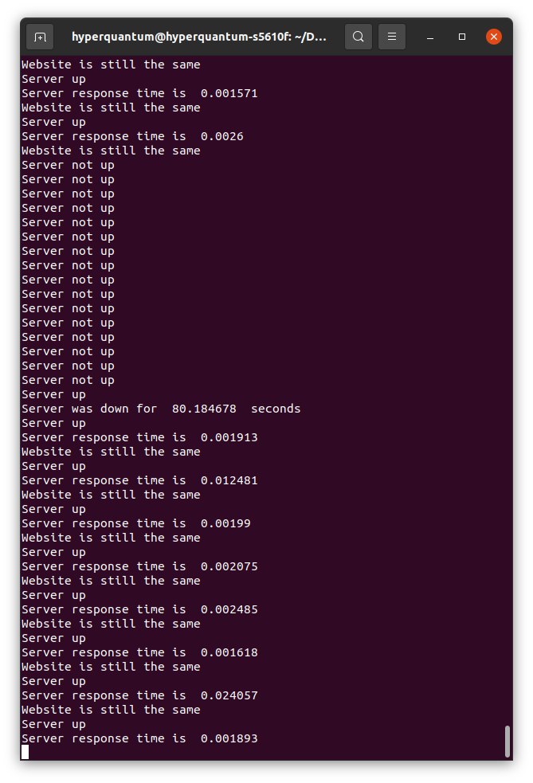

Output from **server.log** while running server script **http_server2.py**

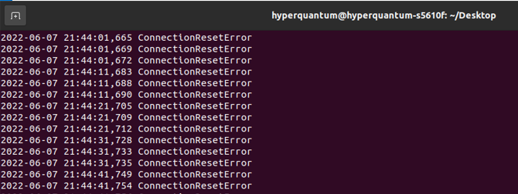

Output from **monitor.log** while runningmonitoring script **check_status3.py**

